**CURRICULAM VITAE**

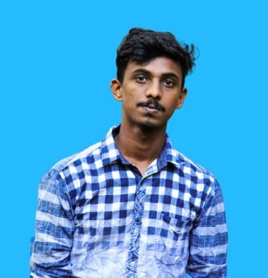

**G YUVARAJ KHARVI**

**Mobile :** 9663585029

Email:-Yuvarajkharvi726@gmail.com

**Address:** G.YUVARAJ KHARVI

S/o Chandra kharvi,

Vantu house ,

Dhakuhithlu gangolli

576216

**Career Objective**

Seeking a position in an organization where my skills and abilities can be creatively utilized to add value to the organization and to attain professional growth and being competent, innovative and resourceful.

Educational Qualification

|  |  |  |  |  |
| --- | --- | --- | --- | --- |
| **Course** | **Name of the Institute** | **Board/ University** | **Year of Passing** | **Percentage** |
| **BCA** | Dr.B.B Hegde first grade college kundapura | Mangalore university | 2021 | - |
| **PUC**  **(Commerce)** | S.V.P.U College Gangolli. | P U E | 2018 | 75% |
| **S S L C** | S.V High School Gangolli. | K S E E B | 2016 | 81% |
|  | | | | |

**Computer skills**

**Programming Languages:** Java, C, C++,Python basics  
**Operating Systems:** Windows 10, Ubuntu, MS-DOS  
**Web designing Languages:** HTML

**Other skills:** web and windows application using VB.net  
**MS office**

**Personal skills**

* Confident
* Team Player
* Presentation skills

**Strengths**

Comprehensive problem solving abilities, good verbal and written communication skills, ability to deal with people diplomatically, willingness to learn, team facilitator, Quick learner, Good communication skills, Willingness to work hard with dedication.

**Hobbies**

* Travelling
* Listening songs
* volunteering

**Language Proficiency**

|  |  |  |  |
| --- | --- | --- | --- |
| **Speaking** | **Writing** | **Reading** | **Understand** |
| English | English | English | English |
| Kannada | Kannada | Kannada | Kannada |
| Hindi | Hindi | Hindi | Hindi |

**Personal Details**

**Name :** G.YUVARAJ KHARVI

**Father’s name** **:** Chandra kharvi

**Date of Birth** **:** 06/09/2000

**Sex :** Male

**Nationality**  **:** Indian

**Declaration**

I hereby declare that all the above information furnished by me is true to the best of my knowledge.

**Date**: yours sincerely

**Place**: Gangolli (**G.YUVARAJ KHARVI**)